**DAILY ONLINE ACTIVITIES SUMMARY**

|  |  |  |  |  |  |  |  |  |
| --- | --- | --- | --- | --- | --- | --- | --- | --- |
| **Date:** | | **29-06-2020** | | | | **Name:** | **Rani M.D** | |
| **Sem & Sec** | | **6th & B** | | | | **USN:** | **4AL17CS075** | |
| **Online Test Summary** | | | | | | | | |
| **Subject** | | | **DBMS and Cyber Security** | | | | | |
| **Max. Marks** | | | **-** | **Score** | | | **-** | |
| **Pre-placement Training Summary** | | | | | | | | |
| **Topic** | **DBMS,**  **Cyber Security** | | | | | | | |
| **Faculty** | Reena Lobo,  Dr. Manjunath Kotari | | | | **Duration** | | | **4hours** |
| **Coding Challenges** | | | | | | | | |
| **Problem Statement**:  **Program to Count the Number of Occurrences of an Element in the Linked List using Recursions** | | | | | | | | |
| **Status: Solved** | | | | | | | | |
| **Uploaded the report in Github** | | | | | **yes** | | | |
| **If yes Repository name** | | | | | Daily Status | | | |
| **Uploaded the report in slack** | | | | | **yes** | | | |

**SNAPSHOTS**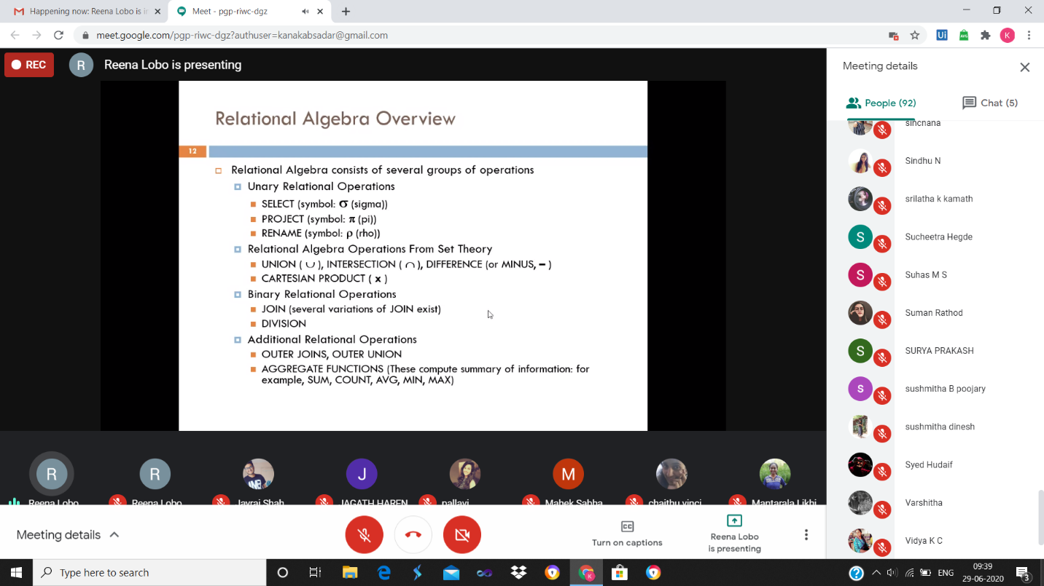

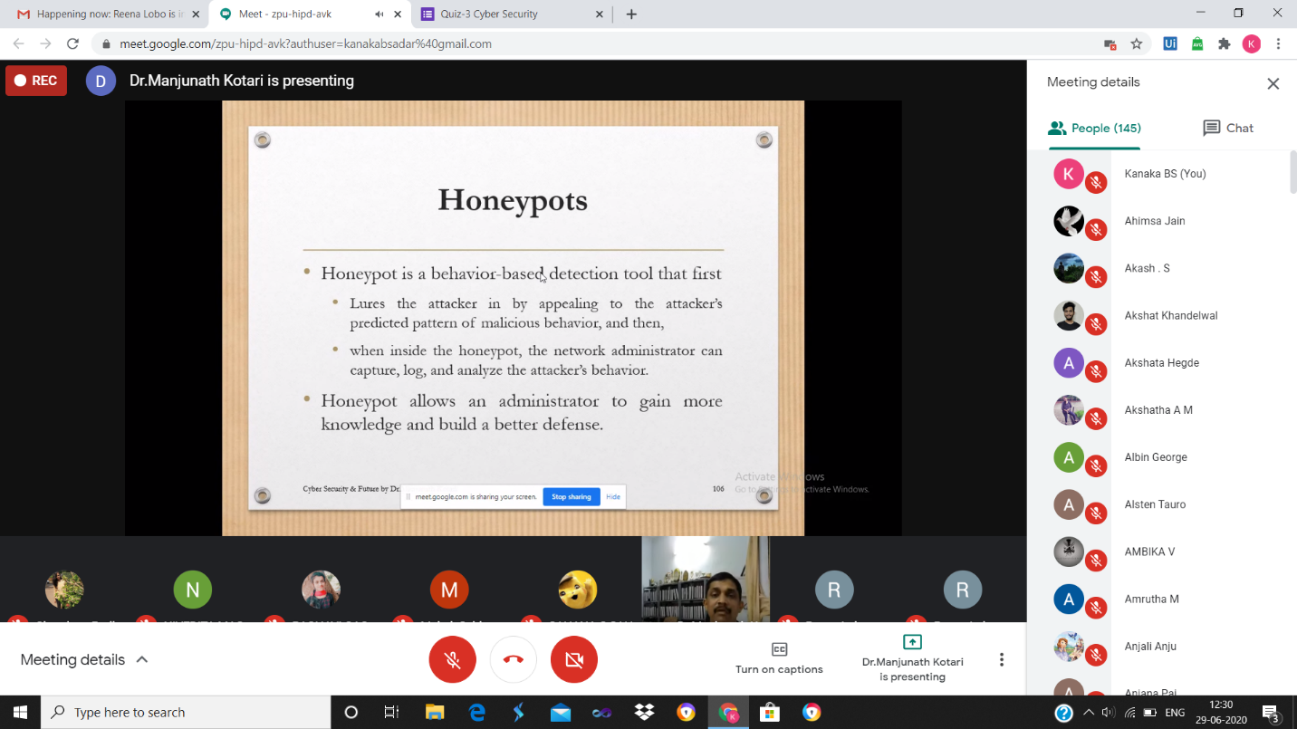

**ONLINE CODING**

**Program to Count the Number of Occurrences of an Element in the Linked List using Recursions**

class Node:

def __init__(self, data):

self.data = data

self.next = None

class LinkedList:

def __init__(self):

self.head = None

self.last_node = None

def append(self, data):

if self.last_node is None:

self.head = Node(data)

self.last_node = self.head

else:

self.last_node.next = Node(data)

self.last_node = self.last_node.next

def display(self):

current = self.head

while current:

print(current.data, end = ' ')

current = current.next

def count(self, key):

return self.count_helper(self.head, key)

def count_helper(self, current, key):

if current is None:

return 0

if current.data == key:

return 1 + self.count_helper(current.next, key)

else:

return self.count_helper(current.next, key)

a_llist = LinkedList()

for data in [9, 4, 9, 4, 7, 3, 9, 1, 2, 3]:

a_llist.append(data)

print('The linked list: ', end = '')

a_llist.display()

print()

key = int(input('Enter data item: '))

count = a_llist.count(key)

print('{0} occurs {1} time(s) in the list.'.format(key, count))

